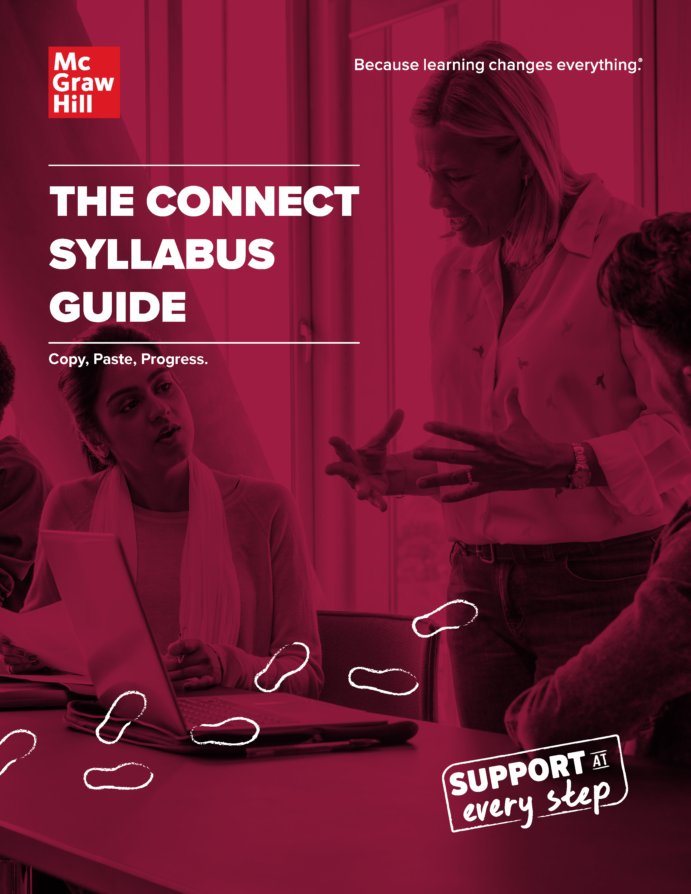

It’s crunch time, but that doesn’t mean you need to be stressed. You have support at every step of your journey, including the creation of your syllabus.

Adding Connect details to your syllabus is quick and easy. Get out your pen – you’ll be checking another item off your to-do list.

In this guide, you’ll find text you can copy and paste into your own syllabus. This content includes helpful details that cover the following:

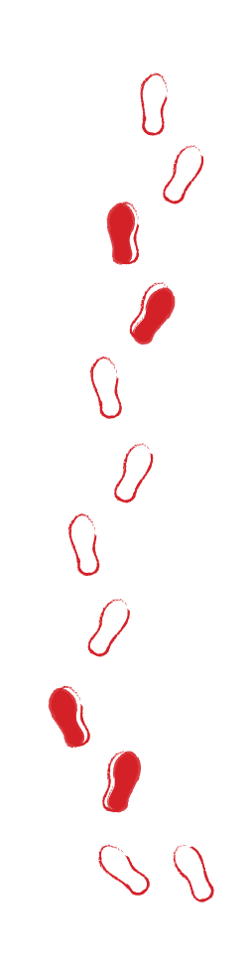
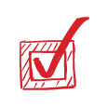
Description of Connect
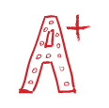
Student Registration and Purchase Information
How Connect Fits into Your Overall Course Grade
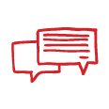
Expectations and Policies Related to Course Assignments
Technical Support Information

Copy & Paste the Following Information into Your Syllabus
A BRIEF DESCRIPTION OF CONNECT
Welcome! In this course we will use {book title, author, edition}. To purchase your text, you have the option of purchasing [an online only access code, or an access code with your print textbook]. Connect uses technology that adapts content to your skill level to make more-efficient use of your study time and create a more effective learning experience.
Here is your REQUIRED course material:

TITLE | EDITION | AUTHOR | PUBLISHER | ISBN
 |  |  | McGraw Hill
What is Connect?

Connect is an online homework and learning management platform from McGraw Hill. Many of your course assignments will be delivered through Connect.
Connect helps you:
- Stay organized with assignments – both in and out of class
- Target difficult material to practice and improve your skills
- Review for exams with self-assessment tests and quizzes
- Track your performance with personalized reports
- Save time on studying
Maximize your Connect registration with ReadAnywhere™
The FREE ReadAnywhere app lets you download the eBook version of your textbook and access SmartBook 2.0 assignments on your smartphone or tablet.*

Download for iOS Download for Android

*Students must purchase Connect to use the ReadAnywhere app. Only available for select titles. iOS and Android supported.

Copy & Paste the Options that Best Apply to Your Course
STUDENT PURCHASE & REGISTRATION INFORMATION
For this course, you will purchase access to McGraw Hill Connect. Here’s how:

OPTION 1 | Purchase from Connect course URL:  Purchase directly from the course homepage at {add Connect section-specific WEB ADDRESS}. During the registration process, you will be prompted to create a new account or login with an existing Connect username and password.  At that time, you will need to do one of the following:  - Enter your access code  - Purchase access online  - Begin your 14-day Free Trial period  Please note: After you purchase full access, you will have the option to purchase a low-cost, binder-ready, loose-leaf, print version of the text through Connect. This is optional. If you choose to purchase a copy, a full-color, loose-leaf version will be shipped to you.
OPTION 2 | Purchase from Connect integrated in {add name of LMS}:  Purchase Connect access through your {insert LMS program} account. Login to your institution’s {insert LMS program} account, and enter your course, then click on the Connect link, which will take you to the Connect registration page where you can follow the prompts.  At that time, you will need to do one of the following:  - Enter your access code  - Purchase access online  - Begin your 14-day Free Trial period  Please note: After you purchase full access, you will have the option to purchase a low-cost, binder-ready, loose-leaf, print version of the text through Connect. This is optional. If you choose to purchase a copy, a full-color, loose-leaf version will be shipped to you.
OPTION 3 | Purchase from the bookstore:  Purchase a Connect code at the bookstore and register either with the provided link or with the link provided by your instructor. During the registration process, you will be prompted to create a new account or login with an existing Connect username and password.  At that time, you will need to do one of the following:  - Enter your access code  - Purchase access online  - Begin your 14-day Free Trial period  Please note: After you purchase full access, you will have the option to purchase a low-cost, binder-ready, loose-leaf, print version of the text through Connect. This is optional. If you choose to purchase a copy, a full-color, loose-leaf version will be shipped to you.
OPTION 4 | Inclusive Access:  Your Connect access for this course is already available to you through your course fees.  The required course materials are accessed directly through {ENTER LMS NAME HERE}  and assignments are available today.

Copy & Paste the Following Information into Your Syllabus
HOW CONNECT FITS INTO YOUR OVERALL COURSE GRADE
Connect is required to complete your assignments and will be worth {insert}% of your grade.

SmartBook Reading Assignments: | %
Assignments: | %
Quizzes: | %
Exams: | %

Copy & Paste the Following Information into Your Syllabus
EXPECTATIONS AND POLICIES RELATED TO COURSE ASSIGNMENTS
All course assignments will be scheduled, completed, and recorded in Connect.
All students are required to complete every assignment by the due date listed.

Copy & Paste the Following Information into Your Syllabus
TECHNICAL AND SUPPORT INFORMATION
If you are having trouble registering for or accessing Connect, please contact McGraw Hill’s Customer Support. Live chat, email, and phone support are available 7 days a week.

When contacting a support agent, you will always receive a case number. It will be important to save this case number if additional follow up or documentation is needed.

Website: mpss.mhhe.com | Phone: (800) 331-5094
Hours (EST)
Sunday: 12 PM - 12 AM
Monday - Thursday: 24 hours
Friday: 12 AM - 9 PM Saturday: 10 AM - 8 PM

Ensure your computer meets system requirements by going to this link:
http://connect.mheducation.com/connect/troubleshoot.do

